External API check up 🚀

Our testing check up requires Postman tool (it’s free, you can download it from here : https://www.postman.com/downloads/)
Before start
1. Import collection via link:

https://api.postman.com/collections/18331496-2a16601a-8b04-41ce-8cc5-d9716074838d?access_key=PMAT-01GZ0ZGYW66FJRYG5H4T2BVMS6
2. Create an environment for collection tests :

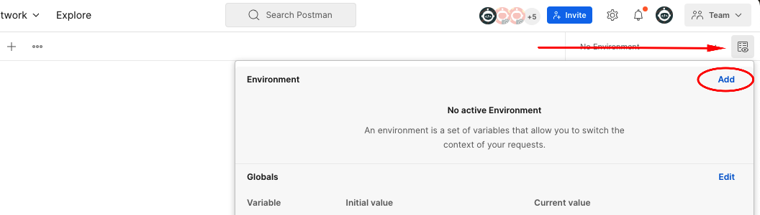

3. Add three variables to environment and fill them with your API URL and credentials
(variables should have the same naming as on screenshot)
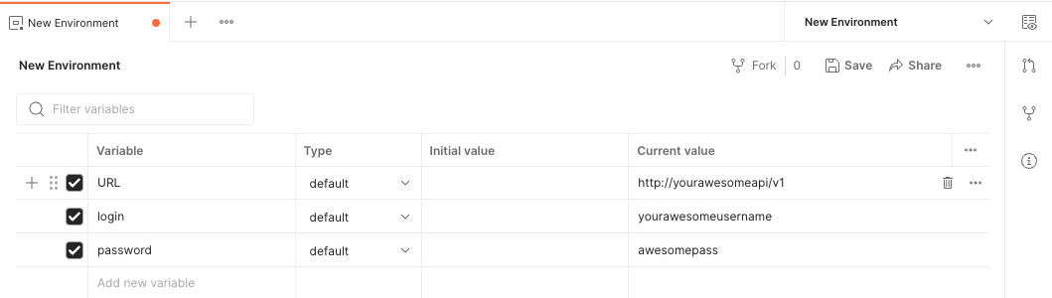

Running collection

1. Open Search 1 request from Search folder and open Pre-request Script tab

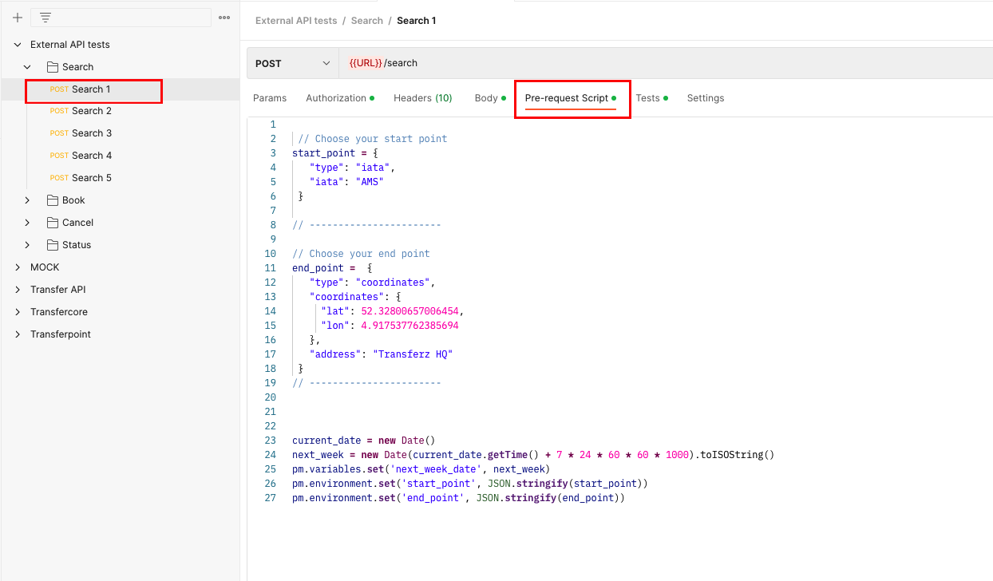

2. Find start_point and end_point variables and put any points that available in your API according to documentation (You can delete values that are set to default)

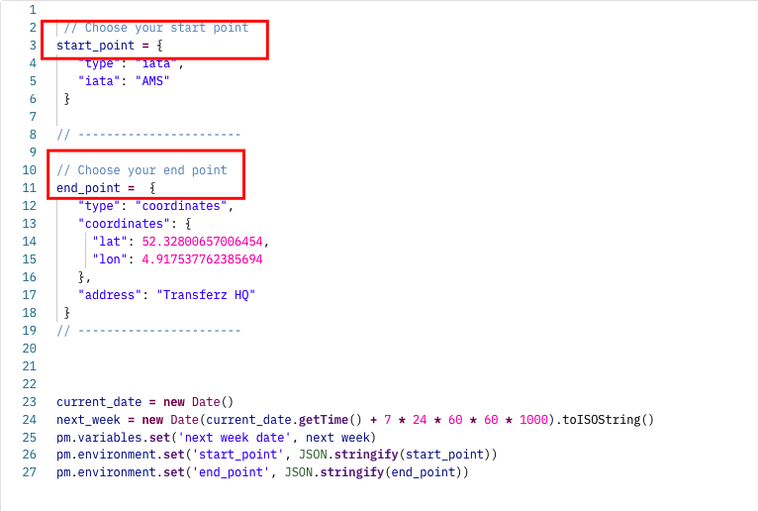

3. Run collection

Find External API tests collection in the list and choose Run collection

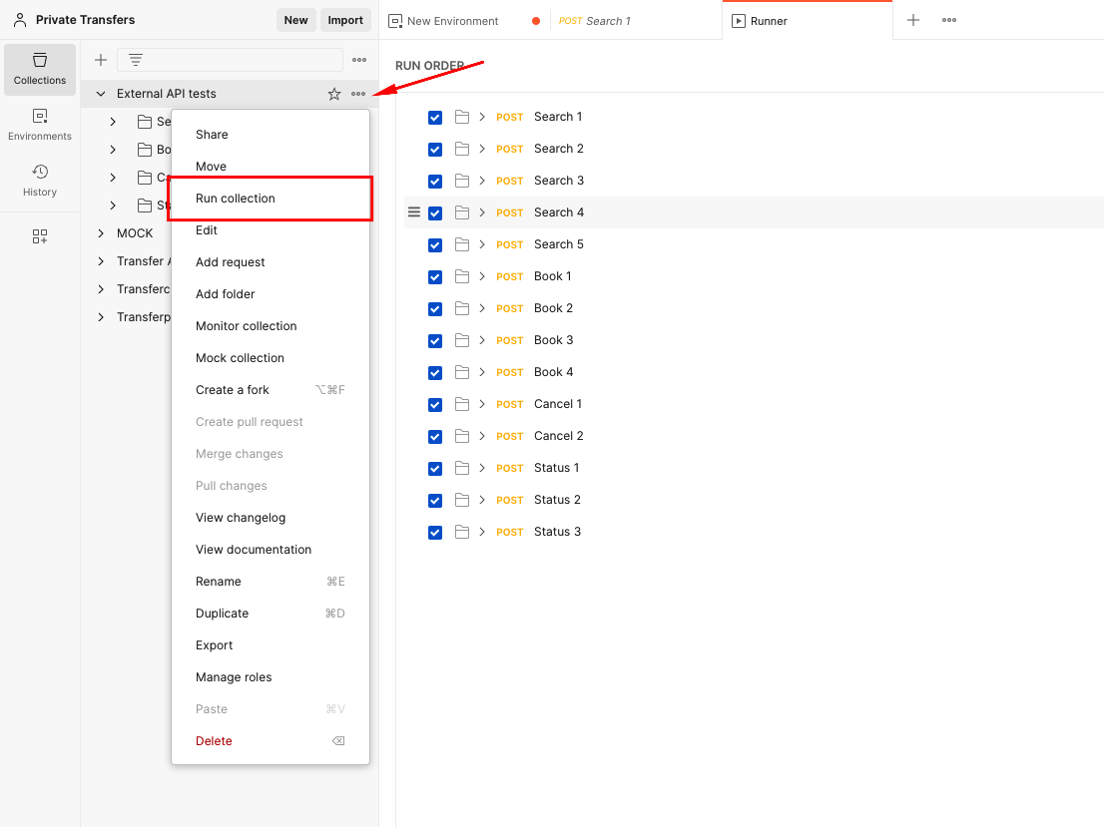

Than press run button to make tests work 🚀

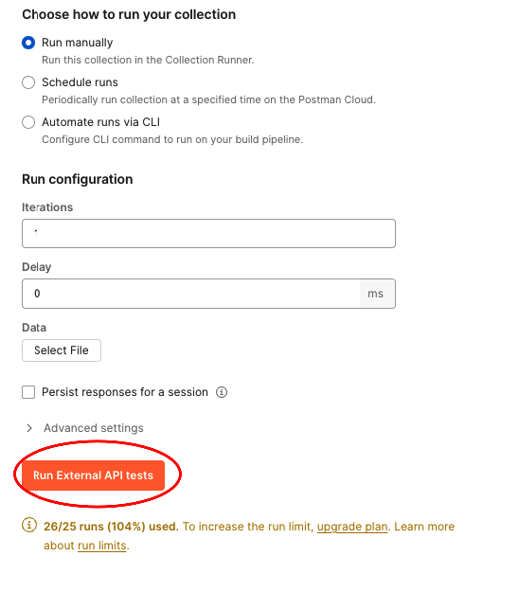

Results

After all requests passed you can see test results. Failed test shows test cases that need to be fixed.
Make a screenshot of the result and send to ETG team.

